Updated Burn down Chart Changes

Updated Burndown chart changes after extra Requests were added in by the Client

This is the Pervious Burdown down chart:

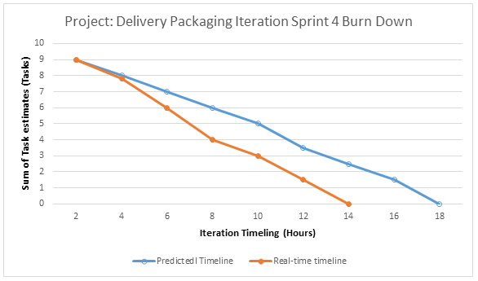

This is after the changes were requested by the Client Team

